Design a world-class service catalog

Product Whitepaper

Updated: October 2024

Asset number: 0003872

**Table of Contents**

Plan for the catalog design process 3

Define the measures of success for your service catalog 3

What are your users’ needs, pain points, and delight factors? 3

What measures of success would help track the catalog’s ability to meet user needs and create greater efficiency? 4

Stage 2 – Design a powerful, user-friendly catalog 5

Outline an initial scope 5

Get discovered with a unified portal and generative AI 5

Taxonomy deep dive 6

Optimize your catalog item design 8

Simplify your request forms 10

Tips and Tricks 14

The takeaway 14

Related resources 14

**Plan for the catalog design process**

Set your catalog up to succeed with a process plan and a team with clearly defined roles.

**KEY INSIGHTS**

* Clarify your catalog design team’s roles and responsibilities.
* Define clear measures of success for your service catalog design.
* Plan an incremental approach to scale your service catalog design deployment.

Organizations typically have aggressive targets for their service catalog deployment, but they under-invest in creating a process to inform service catalog design and maintenance decisions. Without a planned process, service catalog design quickly fails to meet its intended objectives.

Instead, create a process plan that shows a clear understanding of:

* Who needs to be on the design team
* What are the primary user problems addressed by the catalog design
* Where to first apply the new design
* How to scale the new design

**Define the measures of success for your service catalog**

The design (or redesign) of your catalog is a perfect opportunity to revisit and quantify your catalog’s value. To define the metrics aligned with catalog success, we start by understanding common user needs and pain points.

**What are your users’ needs, pain points, and delight factors?**

Through UX Research studies, ServiceNow has identified common needs and pain points for both end users and fulfillers, which can be addressed with a well-designed catalog. Your business may have more than these two generic personas; work with your stakeholders to identify any additional target audiences that may have different needs

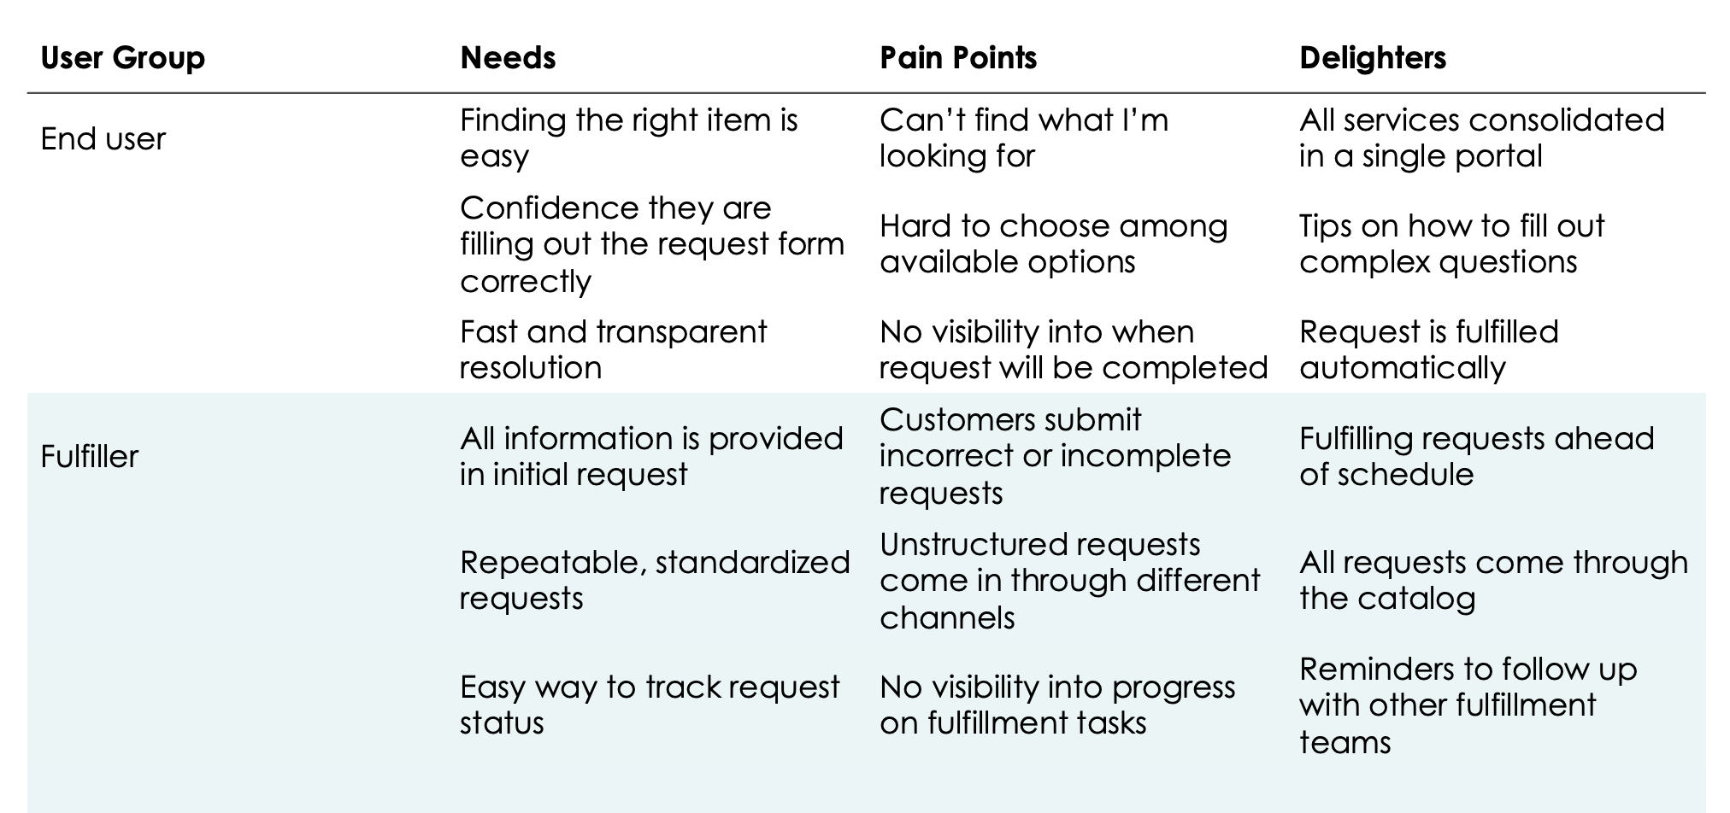

Table 1: Framework for documenting user feedback (shown with examples)

**Note:** If you have a design, user experience, or user research team available, we recommend adding user research as part of your design process.

**What measures of success would help track the catalog’s ability to meet user needs and create greater efficiency?**

Create a set of quantifiable success metrics that you track regularly to highlight trends and gaps in your catalog performance. These metrics serve as triggers for the design team to make progress toward your long-term catalog vision and goals.

There are two categories of goals you should definitely include (but feel free to tailor them to meet your business and user needs): effortless user experience and fulfillment efficiency.

**Effortless user experience design objectives**

* **Provide a one-stop shop for user requests**
  + Measure of success – # of portals users go to for typical business needs (lower is better); Ratio of unstructured tickets to requests
* **Improve search**
  + Measure of success – Average click position; click-through rate
* **Clarify delivery expectations**
  + Measure of success – % of requests displaying estimated fulfillment time; Number of support calls for information and updates on requests made
* **Improve experience**
  + Measure of success – CSAT; Customer effort score

**Provisioning efficiency design objectives**

* **Increase self-service**
  + Measures of success – Increased call deflection; reduced cost per request
* **Streamline processes**
  + Measures of success – % of requests with automated fulfillment; Mean time to resolve
* **Improve predictability**
  + Measures of success – Reduction in touchpoints with end user and between fulfillers;   
    % requests fulfilled within expected SLAs



**Design a powerful, user-friendly catalog**

Your service catalog's success depends on a good user experience. Design one that your users will want to use.

**Key insights**

* Unify your portals
* Customers who upgrade to AI Search see an immediate relevance improvement.
* A well-organized, 3-level taxonomy simplifies user navigation and decision-making.
* Action-oriented catalog items names helps both users and AI understand the request.
* Better guidance within the catalog enables users to quickly make informed choices.

**Outline an initial scope**

Taking a big bang approach to the design of the entire service catalog is ambitious. If you already have executive buy-in for a redesign, along with design and engineering resources, Dream Big! If you do not, it can take months to get everyone’s buy-in on the new design and process the multiple quality and technical issues that pop up.

We recommend starting with a small scope. Prioritize catalog items based on their frequency and impact. Prioritize improving the design and fulfillment of these items. Some items are infrequently requested but their impact is incredibly high. Safety Issues and Pay discrepancies are two examples. Prioritize these next.

Once you have addressed the top requests, lay out a plan to incrementally improve the catalog and get feedback from users.



**Get discovered with a unified portal and generative AI**

Combine all your content into one portal for each user group, like customers and employees. Giving users one place to get help significantly increases the adoption of the catalog and reduces the number of miscategorized requests.

Users find help differently—some search, others navigate menus, and many now start with chat, thanks to widespread familiarity with ChatGPT. Use the latest in content discovery, including AI Search for better search results without extra tuning. Now Assist for Virtual Agent, with its generative AI, offers an exceptional chat experience, streamlining access to your catalog and reducing the need for extensive topic development.

**Create unified portals for distinct personas**

* Establish a single access point for each user segment (customers, employees, etc.).
* This unified approach simplifies service discovery and reduces maintenance.

**Adopt Generative AI for a best-in-class user experience**

* AI Search dramatically improves relevance and user experience.
* Now Assist for Virtual Agent makes getting help feel as easy as having a conversation.

**Optimize taxonomy for user-centric navigation**

* For Employee Portals, start with the Employee Experience Taxonomy, adding as needed.
* Limit taxonomy to 3 levels and 9 topics per level, avoiding navigation complexity.
* Use plain language to identify your categories/topics, avoiding acronyms and jargon.

**Personalize user experiences**

* Leverage user criteria (role, location, etc.) to tailor visible content.
* Align taxonomy with the mental models of employees, not organizational structures.

**Enhance content accessibility**

* Cross-link relevant catalog items for comprehensive topic coverage.
* Associate related articles and catalog items to prevent user dead-ends.

**Taxonomy deep dive**

When designing your portal taxonomy, through which users will find your catalog items, think of a grocery store layout. Grocery aisles are arranged by user needs, not by supplier convenience. Similarly, the design of the taxonomy should focus on user perspectives, not organizational structures. Organizing by internal teams or functions can confuse users, making it hard to find what they need. Aim for 3 to 9 top-level categories that reflect how users think and search, enhancing their experience and catalog adoption.

* **Start broad, then get specific:** Organize from general topics at the top to detailed ones at the bottom.
* **Highlight popular items:** Put the most sought-after items at the top.
* **Link things together:** Connect related items and information to keep users on track without hitting dead ends.

**Define a 3-level taxonomy**

Think of your catalog's structure as a roadmap. It should clearly guide users from broad categories to the exact thing they need. Keep the taxonomy to three levels of depth: top-level topic > subtopic > subtopic > catalog item. Start the most general at the top to the most specific at the bottom.

After defining your top-level topics, make sure you have one or two levels of subtopics. Any more than that will require too many clicks for users to get to the catalog items. Within each topic, there should be between three and nine subtopics. If there are fewer than three, you can combine the content into the higher-level topic. If there are more than nine, combine topics together or add an additional level of hierarchy.



**Figure 1:** Example of a 3-level taxonomy: HR > Pay and Time > Compensation

Considering adding new topics? Use a [tree-test](https://www.servicenow.com/community/user-experience-sig/from-the-experts-tree-testing-methodology-for-organizing-your/ta-p/2553440) to make sure they're where users would naturally look for them. If you're creating your catalog from the ground up, card sorting is a great method to organize it in a way that makes sense.

| **How to do card-sorting exercise** |
| --- |
| * Give each person a set of cards that have different category names on them. * Show them a list of things from your catalog and ask them to sort these items into the categories on their cards. They can change, remove, or add new categories as they see fit. * When everyone's done, record all the different ways they sorted the items. It's also important to note what people said about their choices and which cards were often grouped together. * Based on this information, confidently create new categories and meta tags that align with your users’ communication styles. |

**Top questions and answers on taxonomy**

**How many items should be in my catalog?**

It's okay to have lots of items, even thousands, as long as they're well-organized and easy to find.

**Can an item appear under several topics?**

Yes, you can list an item in more than one place to help different users find it easily.

**Should we have different items for each option?**

It's better to group similar things together, like having one item for an iPhone with different color options, but balance this with how complex it makes things to manage.

**What if an item doesn't fit any topic?**

For items that don't fit into existing topics, make an "other" category. They'll still be findable through search or Virtual Agent. Over time, as your catalog evolves review the “other” category to see if items now have a common home.

**How often should we update our taxonomy?**

Review your taxonomy twice per year to ensure it stays consistent with organizational changes. Use this opportunity to retire underused items. It will streamline user navigation.

**Optimize your catalog item design**

* Simple, action-oriented names make it easy to identify the correct item
* Reduce the complexity of request forms to increase requests correctly submitted
* Provide guidance for complex requests

**Name your catalog items for your users**

Using a service catalog should be as intuitive as using your favorite app. The key? Clear, action-oriented names.  
  
**Keep it action-oriented**

Use verbs in names: "Update," "Enroll," "Remove." Avoid vague terms like “Management”.   
When was the last time someone called in with an urgent need for “Active Directory group management”?

* Instead of "Offboarding request," use "Offboard an employee."
* Swap "Active Directory group management" for "Add user to Active Directory group."
* Replace general terms like "IT issues" with specific actions like "Report a computer problem."

Additional examples of clearly named catalog items:

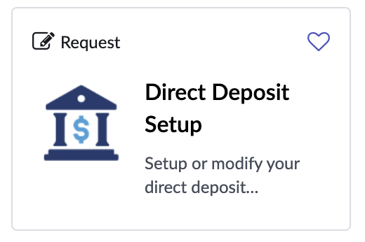  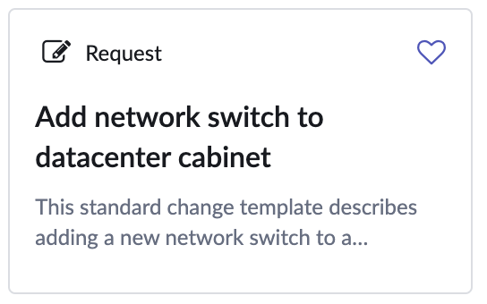  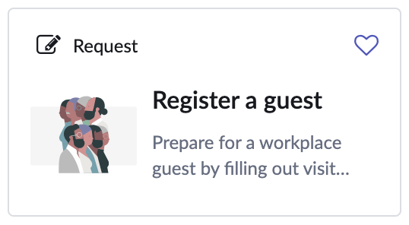 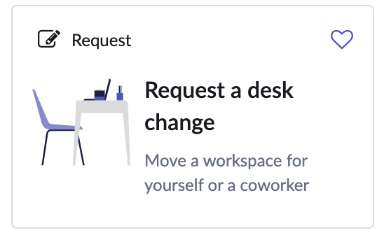 

**Reflect user needs**

Names should match how users think, not your team's structure. To find out what users look for:

* Check search query logs.
* Review virtual agent interactions.
* Read submitted incidents and requested items.
* Check the “catch-all” catalog items (e.g. Report an IT issue) for recurring themes.

**Make content easy to find**

* Use plain language for clear, understandable names; avoid acronyms and jargon.
* Include detailed descriptions and relevant keywords.

**Give your users the important info**

Your catalog should have all the info users need to confidently file the right request. Go above and beyond for clarity and transparency, and you’ll be rewarded with more usage and successful submissions.

* **Service definition**

Describe each service clearly. What does it do? How does it help?

* **Pricing**

Be upfront about costs.

* **Delivery time**

Set clear expectations for how long the service will take.

* **Approval process**

Explain any necessary steps for approval.

* **Contact information**

For new services, adding contact information for questions can be helpful. Remove this once you've fine-tuned the user experience based on feedback.

Tailor the information to your audience. Use the ServiceNow [user criteria](https://docs.servicenow.com/csh?topicname=t_CreateAUserCriteriaRecord.html&version=latest) to show relevant items based on user location, function, or job type. This approach ensures users only see the items that are available to them, making the catalog more effective and user-friendly.

**Simplify your request forms**

Fewer questions on your request form mean more requests are submitted correctly. Autofill questions with information available in-platform. Use Integration Hub to fill in information from other systems.

Ask for information users either have or know how to get. If they can't complete the form correctly because they don't know where to find the information, give hints:

* Sensible defaults

Field: Requester Name  
Default: Set it to auto-fill with the user's name

* User guidance

Field: Laptop Serial Number   
Hint: “Found on the back of your device.”

**Keep questions to a minimum**

If you want to improve your service catalog's user experience, try to minimize and optimize the questions you ask. This will make your service request process more accurate and efficient.

* **Ask only what's necessary**

Figure out the least information users need to provide, and let the system handle the rest.

* **Smartly use existing data**

Automatically fill in answers using reliable data. If the data might be outdated, pre-fill it and ask users to confirm or give them a way to update the outdated data.

* **Limit mandatory fields**

Make sure every required field is truly essential. If users can't complete a field, they might submit a nonstandard request instead.

* **Use what you ask for**

Only request information that you'll actively use. If a user’s request is going to get treated the same regardless of its urgency, don't ask how urgent their request is.

**Avoid acronyms and jargon**

Requesting something shouldn't feel like decoding a puzzle. It's crucial to use straightforward language that everyone can understand.

* **Full terms over acronyms**

Skip the shorthand. Use complete terms that are clear to all, not just those familiar with the service owners.

* **Jargon-free descriptions**

Dive deep into your catalog. Ensure names, descriptions, and even field options are jargon-free. Confusing terms lead to more incidents as users struggle with unclear choices.

* **User-Friendly questions**

Consider the user's perspective. Are they the right person to provide certain information? Sometimes, rephrasing a question can guide users more effectively than technical queries.

| **Important** |
| --- |
| Want a simple request form? Get detailed. Label each option in a reference fields or choice lists in plain, nontechnical terms. If you ever need to use technical language, be sure to give your users plenty of guidance to find the option they need. |

**Be your users' guide**

This means thinking beyond layouts and databases and focusing on how users interact with each element of your catalog. From providing clear examples and in-depth field help to setting accurate expectations and ensuring unique, non-overlapping items, each aspect plays a key role in enhancing the overall user experience.

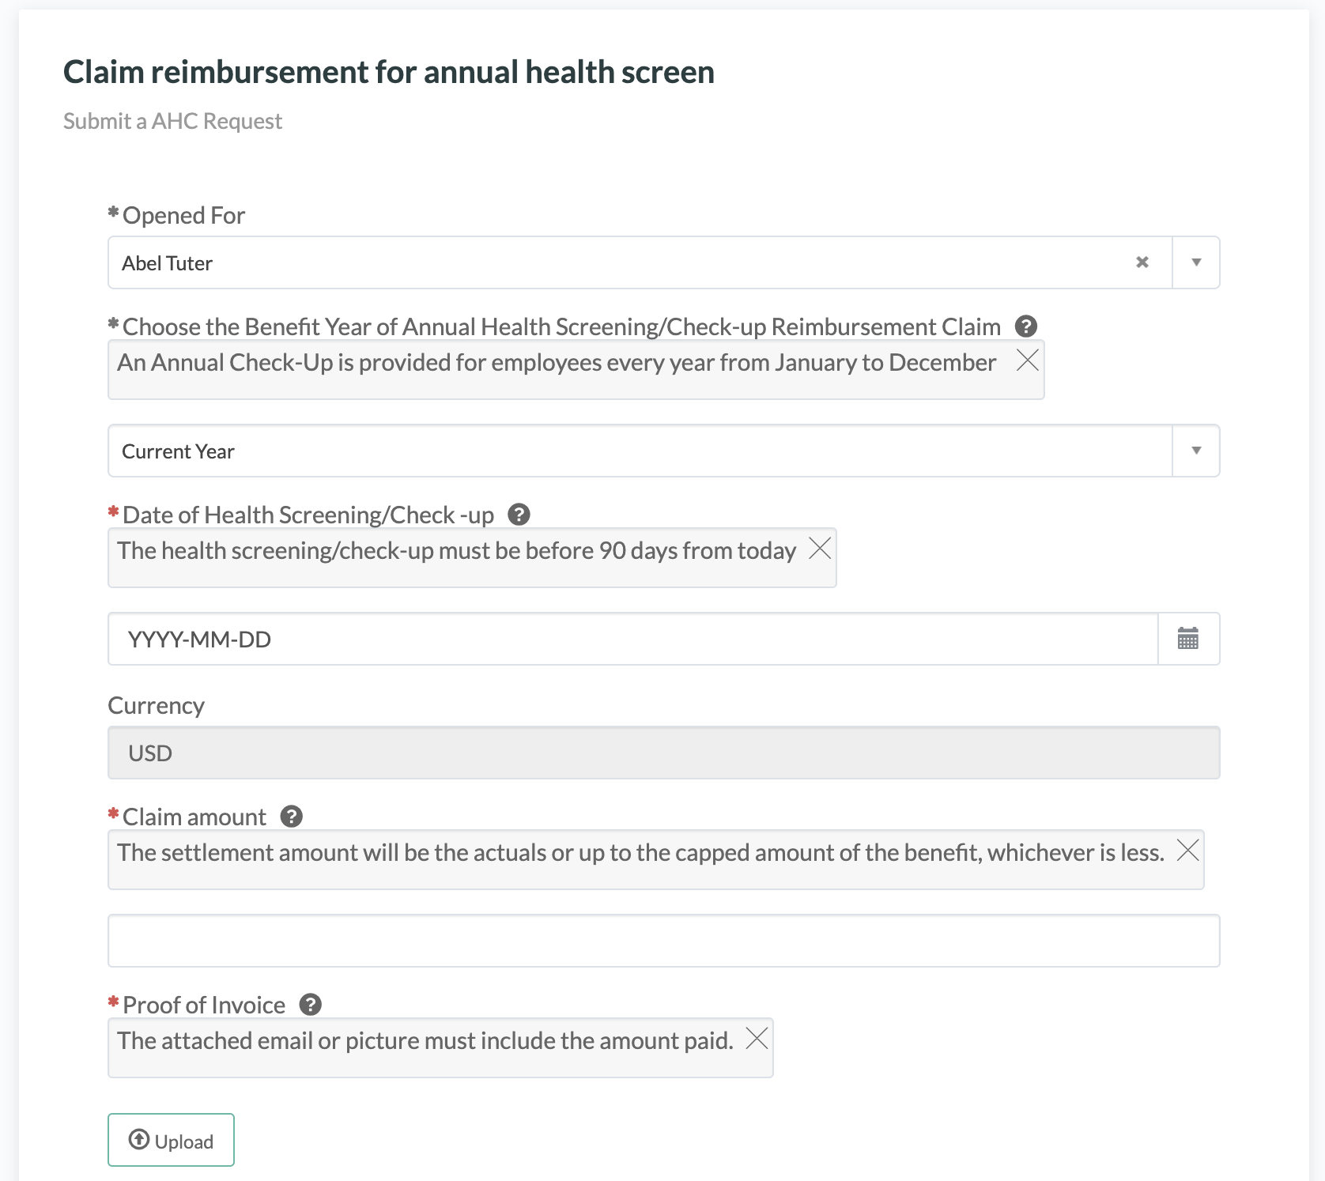  
**Figure 2: Example of a catalog item with annotations to provide clarity and guidance**

* **Lead with examples:** Offer hints and examples to help users input information correctly.
* **In-depth field help:** Use hints for extra clarity on tricky questions.   
  Note: Hints are often an indicator that question labels should be clarified.
* **Support for complex forms:** Employ labels or rich text to provide context where needed.
* **Guidance for hard-to-find info:** If a field can't autofill, give directions on where to find the necessary information, like job codes or order IDs.
* **Set clear expectations:** Provide an estimated time of completion to reassure users their requests haven't been lost.
* **Distinct, non-overlapping items:** Ensure each catalog item is unique to avoid confusion about what to submit.

**Connect with images**

Using imagery in your service catalog can greatly boost user experience and engagement. Make your catalog visually appealing and easy to navigate by using images or icons for each item. If design resources are limited, generative AI tools can do wonders.

  
Figure 3: Three catalog items with rich images

* **Detail and diversity**  
  Include images or icons for every catalog item. This visual representation aids in quick identification and improves user comprehension.
* **Visual harmony**  
  Maintain a consistent style and color palette across all images and icons. This consistency contributes to a professional, unified look.
* **Leverage AI tools**  
  Use AI-based design tools to create high-quality images, especially useful when facing resource constraints.

**Tips and Tricks**

* Don't promote the "Request something else" form on the homepage, but make sure that it is accessible, so users don't hit a dead end.
* Can your users request things on behalf of others? Use a "Requested For" field type instead of a sys_user reference field. [Here's a great blog article](https://www.servicenow.com/community/itsm-blog/hidden-gems-requested-for-variable-type/ba-p/2293465) on this strategy.
* Stay Safe! Ensure creating catalog client scripts have "Isolate script” set to true, to protect your client-side environment.
* Automation discovery can help you quickly identify similar nonstandard requests from which to create catalog items.
* When showing multiple columns in a reference field to help users identify the correct option, order columns by their helpfulness. In Virtual Agent, where there is only room to display two columns, they will be shown in the listed order.

**The takeaway**

As you design your world-class service catalog, remember these things:

* Give users one place to find all corporate services. Then, watch your catalog adoption soar.
* Content discovery is critical to creating a world-class customer experience. AI Search, Now Assist for Virtual Agent, and a Unified Taxonomy are central to helping users find what they need.
* Reduce the complexity of request forms by simplifying names, reducing questions, and providing guidance where help is needed.

**Related resources**

* [Success Quick Answer – What should I consider when configuring a Service Catalog?](https://www.servicenow.com/content/dam/servicenow-assets/public/en-us/doc-type/success/quick-answer/service-catalog-configuration.pdf)
* [Now Learning: User Experience (UX) for ServiceNow](https://nowlearning.servicenow.com/lxp/en/now-platform/from-the-experts-user-experience-ux-for-servicenow?id=learning_path_prev&path_id=3485e25fc39aa5101ac0f60f05013176)
* [User experience reference cards](https://www.servicenow.com/community/user-experience-sig/from-the-experts-download-the-leading-practices-reference-cards/ta-p/2543473)
* [ServiceNow Docs: Unified Taxonomy for Employee Center](https://docs.servicenow.com/csh?topicname=config-taxonomy.html&version=latest)
* [ServiceNow Conversational Interfaces Academy Playlist](https://www.youtube.com/playlist?list=PLkGSnjw5y2U79gjQuQW-2GBqzEccwFkWH)
* [Conversational Interfaces Academy - Building conversations using human design principles](https://www.youtube.com/watch?v=zJVGm1GpDpQ&list=PLkGSnjw5y2U79gjQuQW-2GBqzEccwFkWH&index=18&ab_channel=ServiceNowCommunity)
* [Employee Center Academy: Design techniques to kick start your Employee Center deployment](https://www.youtube.com/watch?v=6rWzoVVXsgU&list=PLkGSnjw5y2U5SRs6n1KBRVNzRjJ1ztbjH&index=15&ab_channel=ServiceNowCommunity)